Udaipur Smart Cities - Air and Lake Water Smart Monitoring Systems

Lake water and Air monitoring system is comprehensive solution that continuously monitors the water and air quality respectively. It is an ecological approach that allows you to monitor multiple water and air quality parameters with a fully integrated, easy to use, economical system. The sensors measure these various parameters, and the data obtained is processed and stored on the cloud server. This enables to get access to real time that can be viewed on a public display unit or a mobile application. The mobile application also gives the historic data and advanced analytics on the data. The real time monitoring enables to stay abreast of constantly changing water and air quality, and address potential issues before they develop into larger problem.

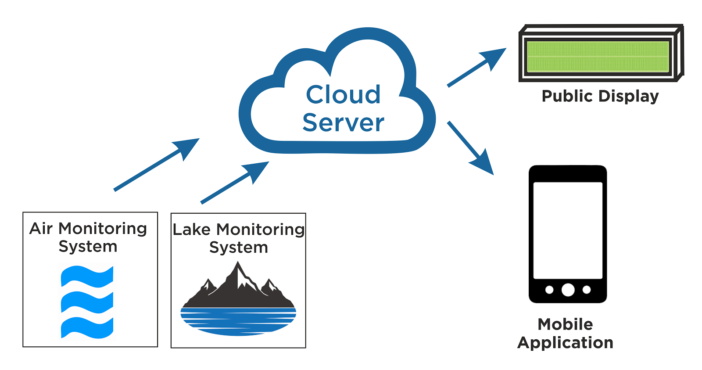

Fig 1: Working Principle

Air Monitoring System Standalone Accurate real-time outdoor air quality Measurement System
Air quality monitoring system is fully integrated monitoring system package – gases, particles and environmental parameters are measured, logged and reported simultaneously. It balances the need for accurate air quality measurement with the need for data that is robust, reliable and defensible. And it’s easy to get data of any location, with secure wireless communication and
a cloud based user interface, your data is protected and available wherever and whenever you need it.
Key features
- Real-time measurement of common pollutants according to WHO air quality standards
- Compact size for ease of installation
- GSM 4G based data logging system
- Remote data acquisition system with fail safe on board storage
- Temperature control permits long-term operation in extreme climates
- Remote calibration and service facility
- In built Auto-Calibration
- Optional plug and play environmental sensors

Sensors

Sr. No. | Gas  Modules | Range (ppm) | Resolution | Noise  Zero/ppm;  Span % of reading | Lower detectable  limit/ppm | Precision | Linearity  (% of FS) | Drift 24hr  Zero/ppm;  Span % of FS
1. | Ozone O₃ | 0-0.4 | 0.001 | <0.001;  <1% | 0.001 | <2% of reading or 0.002 ppm | <1% | 0.001;  0.2%
2. | Nitrogen Dioxide NO₂ | 0-0.1 | 0.001 | <0.001;  <1% | 0.001 | <3% of reading or 0.003 ppm | 1% | 0.001;  0.2%
3. | Carbon Monoxide CO | 0-20 | 0.001 | 0.020;  <1% | 0.040 | <3% of reading or 0.050 ppm | <1% | 0.02;  0.2%
4. | Sulfur Dioxide SO₂ | 0-10 | 0.001 | 0.004;  <2% | 0.009 | <3% of reading or 0.009 ppm | 1% | 0.001;  0.2%
5. | Nitrogen Oxide NO_{x} | 0-0.5 | 0.001 | <0.001;  <1% | 0.001 | <3% of reading or 0.003 ppm | 1% | 0.001;  0.2%
6. | Hydrogen Sulfide H₂S | 0-8 | 0.001 | 0.006;  <2% | 0.012 | <3% of reading or 0.012 ppm | 1% | 0.001;  0.6%
7. | Carbon Dioxide | 0-2000 | 1 | <5;  <1% | 10 | <3% of reading or 10 ppm | 2% | 1;  0.6%
8. | Volatile Organic Compounds VOC | 0-20 | 0.001 | 0.005;  <1% | 0.010 | <2% of reading or 0.010 ppm | <1% | 0.005;  0.2%

Sr. No. | Particle Modules | Sizes | Range | Accuracy | Flow Rate | Lower Detectable Limit (2$σ)$
1. | Particle Monitor (nephelometer) | PM1, PM2.5, PM10 or TSP | 0 to 1800 μg/m3 | <±(2 μg/m3 + 5% of reading) | 2.0 LPM | <1 μg/m3
2. | Particle Profiler (OPC) | PM1, PM2.5, PM10 and TSP | PM1 - 170 μg/m3  PM_{2.5} - 2000 μg/m3  PM₁₀ - 4500 μg/m3  TSP - 5000 μg/m | <±(5 μg/m3 + 15% of reading) | 1.0 LPM | <1 μg/m3

Additional Product Features
- Internal Temperature & Humidity Sensor (-40 to 120° C; 0-100% RH)
- Wireless Sensor Networks
- Communication Interface Wi-Fi and GSM 4g Network
- Industry grade IP65 enclosure with insulated aluminium construction
- Power Module (230-240 VAC, 50Hz)

Applications
- Outdoor air monitoring
- Roadside air monitoring
- Industrial Environment monitoring
- Environmental impact assessments
- Research and consultancy projects

Lake Water Monitoring System Lake water monitoring system is an integrated system that allows you to measure water quality based upon several parameters like temperature, pH level, amount of dissolved oxygen, turbidity etc. It is a well-grounded solution that provides access to real time as well as historical data stored on cloud.

Sensors
Sr. No. | Name | Description | Range | Scan Rate | Default Scan Rate | Type
1 | Temperature Sensor | Measures temperature of water | -20 to +70 degree C | 1 min to 24 hours | 10 min | Programmable
2 | pH Sensor | Measures pH level of water to | 4 to 9 | 1 min to 24 hours | 10 min | Programmable
3 | Turbidity Sensor | Measures purity/ cleanliness of water | 0 to 100%  0 = clean water  100 = turbid water | 1 min to 24 hours | 10 min | Programmable
4 | Level Sensor | Non-invasive, surface level measurement of lake water | 0 to 20mtrs | 1 min to 24 hours | 10 min | Porgrammable
5 | D.O. Sensor | Measures dissolved oxygen in lake water | 0 to 100%  0 = less oxygen  100 = nominal oxygen | 1 min to 24 hours | 10 min | Programmable

Additional Product Features:
- Solar Panel: Entire automation system is powered through solar panel. The solar panel is mounted on lake automation panel in clear sunlight area. (Output - 12V, 500mA)
- Control Box: It is the heart of the automation which consists of GSM based controller with battery backup and solar powered battery supply.
- Mechanical Structure: PVC based mechanical structure provide stable, rugged construction and is corrosion and hazard proof.
Applications
- Inland lake monitoring
- Source water protection
- Environmental impact assessments
- Research and consultancy projects

Air Quality Monitoring Application

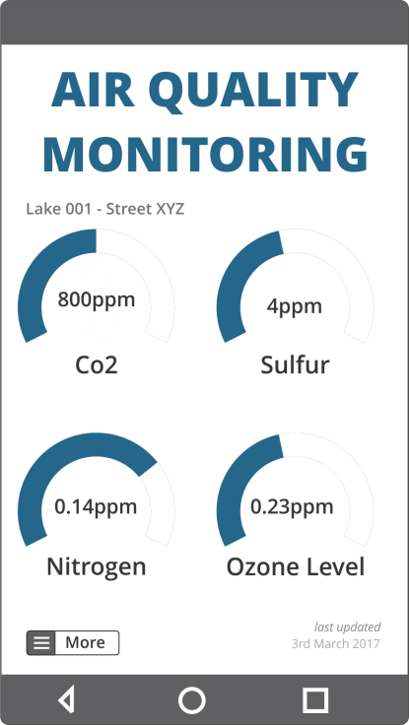 | 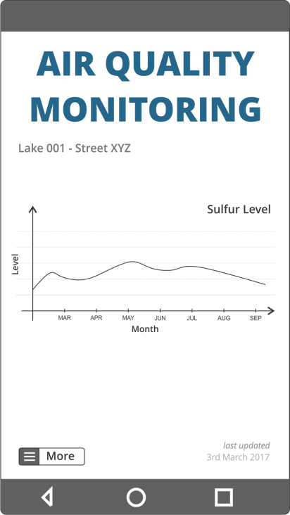 | 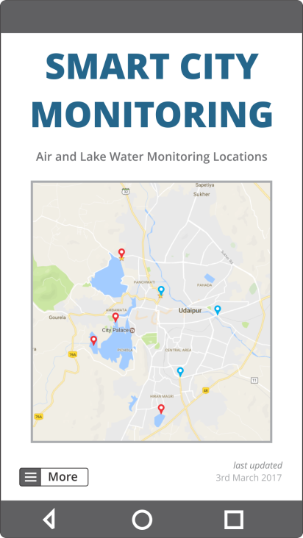
Real Time Data | Historical Data | Location Based Access
Fig 2. Mobile Application View

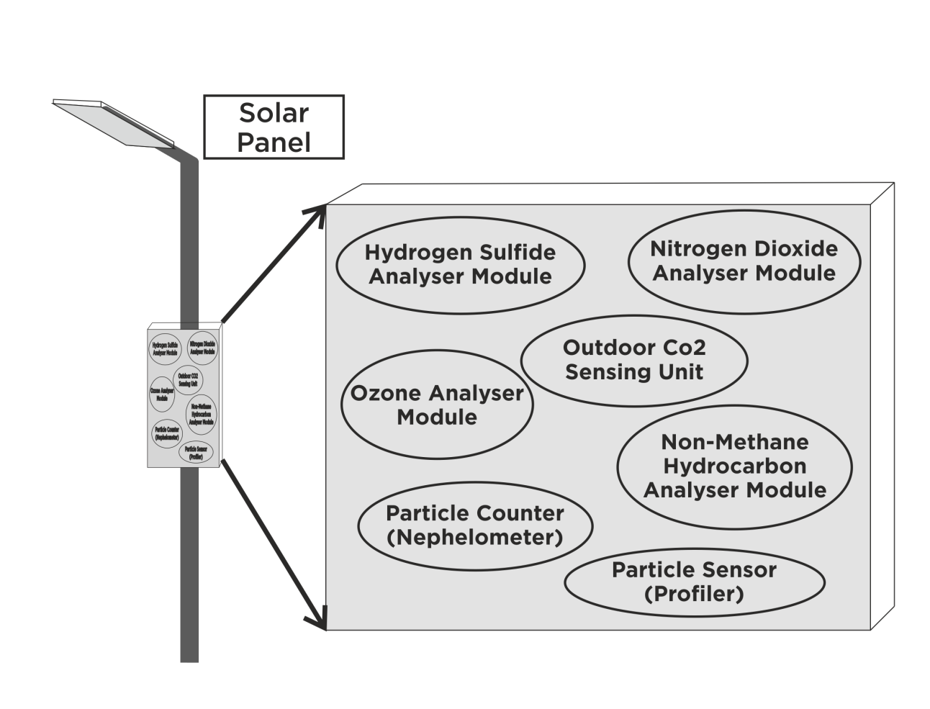
Fig 3. Air Quality Monitoring System

Mobile App Specifications
- Manage and access privileges so only authorised users can access with usernames and passwords
- Get location based real time data of air quality. The blue markers indicate cities with air monitoring applications and red markers indicate cities with lake water monitoring applications.
- Pictorial representation of real time data of pollutants
- View historical data stored on cloud in graphs.

Advanced Specifications
- Predictive Analysis using Machine Learning and Artificial Intelligence to schedule maintenance runs and to predict critical levels.
- Get timely alerts of pollutant level by push notifications.
- Ability to export data in .csv format.
- Advanced Analytics on data collected from cloud server.

Lake Water Monitoring Application

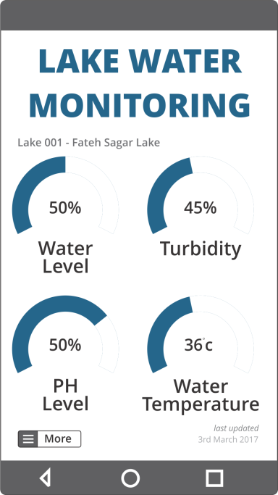 | 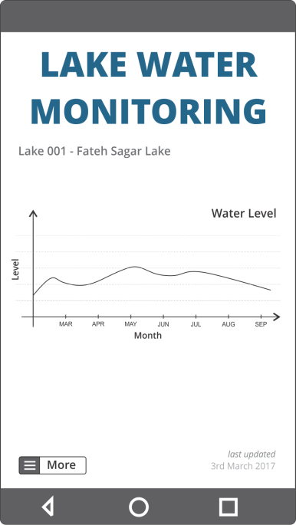 | 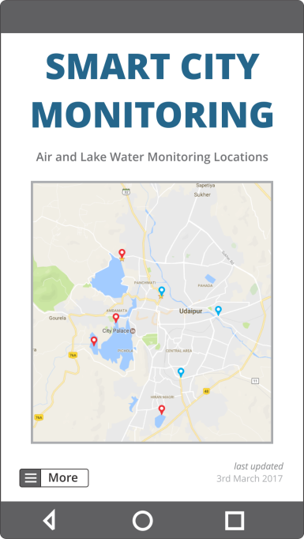
Real Time Data | Historical Data | Location Based Data

Fig 4. Mobile Application view

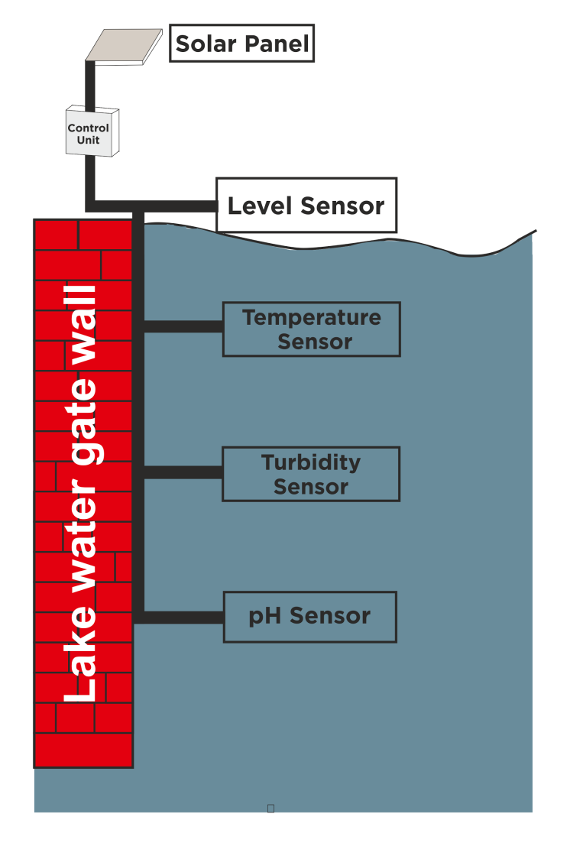
Fig 5. Lake Water Monitoring System

Lake Water Monitoring Specification

Mobile App Specifications
- Manage and access privileges so only authorised users can access with usernames and passwords
- Get location based real time data of water quality. The blue markers indicate cities with air monitoring applications and red markers indicate cities with lake water monitoring applications
- Pictorial representation of real time data obtained from sensors.
- View historical data stored on cloud in graphs.

Advanced Specifications
- Predictive Analysis using Machine Learning and Artificial Intelligence to schedule maintenance runs and to predict critical levels.
- Get timely alerts of water pollutant level by push notifications.
- Ability to export data in .csv format.
- Advanced Analytics on data collected from cloud server.

